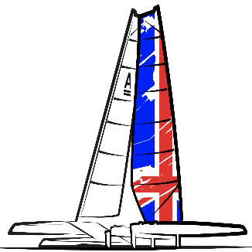

Sailing Instructions
A Class National Championships 2023
Saturday 17th June – Sunday 18th June
Clacton Sailing Club
The Esplanade, Holland-on-Sea, Clacton-on-Sea CO15 5TU, UK

RULES

The regatta will be governed by the rules as defined in the Racing Rules of Sailing (RRS).

When on the water competitors shall wear adequate personal buoyancy at all times except for short periods when changing clothing. Wetsuits and dry suits are not adequate personal buoyancy. This changes RRS 40.

NOTICES TO COMPETITORS

The Race Office will be upstairs inside the clubhouse. Official communications will be posted on the designated Official Race Notice Board in the Club House.

CHANGES TO SAILING INSTRUCTIONS

Any change in the sailing instructions will be posted not later than 60 minutes before the advertised warning time of the race or races concerned, except that any change to the schedule of races will be posted by 2000 on the day before it will take effect.

SIGNALS MADE ASHORE

Signals made ashore will be displayed at the designated flagpole which is a halyard on the Club Starting Hut.

When flag AP is displayed ashore, ‘1 minute’ is replaced with ‘not less than 30 minutes’ in the race signal AP.

SCHEDULE OF RACES

A maximum of 6 races will be sailed for all fleets. The Race Committee may increase the number of races on any day to a maximum of 4 - without making a change to the Sailing Instructions – on the water; this will be indicated by the Committee Boat displaying Flag ‘W’.

Schedule
Day | Date | Event | Time
Saturday | 17-06-2023 | Competitor Briefing  Races 1-3 | 11:00  12:30 (First Start)
Sunday | 18-06-2023 | Races 4-6 | 10:30 (First Start)

5.2 Races will be sailed back-to-back.
5.3 No race will be started after 15.30 on Sunday 18th June 2023.

CLASS FLAGS

The class flag for both foiling and classic will be posted on the official notice board prior to the competitors briefing.

RACING AREA

The racing area will be off the beach of the clubhouse. See ‘Appendix B: Sailing area ‘

THE COURSES

The diagram in the Appendix A: Courses shows the course(s), the order in which marks are to be passed, and the side on which each mark is to be left.

The approximate magnetic bearing of Mark '1' from the Committee Boat may be displayed on the Committee Boat before the warning signal.

The number of laps will be displayed on the Committee Boat before the warning signal.

MARKS

Rounding marks will be orange cylindrical inflatable marks, approximately 1.5m high. A spreader mark may be used. If a spreader mark is to be used, competitors will be notified in the briefing. The spreader will be located 50m to port of 1 and shall be passed to port.

Starting marks will be a race committee boat at the starboard end, including any attached boats or buoys, and either an orange or white spherical buoy approximately 0.5-0.8m in diameter at the port end with an orange flag attached.

Finishing marks will be a race committee boat, including any attached boats or buoys, at the starboard end and either an orange or white spherical buoy approximately 0.5-0.8m in diameter at the port end.

LOCAL NAVIGATION REQUIREMENTS AND AREAS OF OBSTRUCTION

Competitors are reminded of their personal responsibilities for complying with International and National Regulations and Local by-laws governing marine navigation.

THE START

The starting line will be between a staff flying an orange flag on the Race Committee boat at the Starboard end and the Port end start mark.

A boat starting later than 5 minutes after her starting signal will be scored Did Not Start. This changes RRS A4. & A 5

Both foiling and classic fleets will start on the same start.

Boats whose warning signal has not been made shall avoid the starting area during the starting sequence for other races.

CHANGING THE NEXT LEG OF THE COURSE

To change the next leg of the course, the race committee will either lay a new mark of a different colour or move the original mark. In the case of a new mark, they will remove the original mark as soon as practicable. If there is a subsequent change the “new” will be replaced by an original mark.

The race committee can change the course up to 150m in any direction without signalling a change of course. This changes RRS 33.

RRS 33 (a) (2) is modified in that the shape of the flag or board shall have no significance.

SHORTENING COURSE

Courses may be shortened:

When the leading boat of each fleet approaches Mark 2S/2P by the Committee Boat displaying flag S with two sounds. Boats shall pass Mark 2P on the correct side and sail directly to the Finish Line as defined in SI 14. For the convenience of competitors, another boat appointed by the Race Committee may repeat the display of flag S near Mark 2S/2P with repeated sound signals to draw attention to the shortened course, but this does NOT change the requirement to finish as defined in SI 14.1. This changes RRS 32.2 (a), (b) and (c).

THE FINISH

The finishing line will be between a staff flying an orange flag on the Race Committee boat at the Starboard end and the port end finishing mark.

PENALTY SYSTEM

The Scoring Penalty, RRS 44.3, will not apply.

A boat that has taken a penalty or retired under RRS 31 or 44.1 shall make a declaration to this effect at the same time as signing off (see SI 19.1).

RRS 44.1 is changed so that the Two-Turns penalty is replaced by a One-Turn penalty.

RRS Appendix 'P' will apply. The Race Committee and specifically nominated Rescue Boat crews are designated observers for the Protest Committee in the application of RRS Appendix P.

TIME LIMITS

Competitors must finish within 20 minutes of the first boat of the class, classic and foiling. Competitors failing to finish within 20 minutes will be scored DNF without a hearing.

PROTESTS AND REQUESTS FOR REDRESS

Protest forms are available at the clubhouse. Protests and requests for redress or reopening shall be delivered there within the protest time limit.

The end of protest time is 30 minutes after the last boat that has raced reaches the shore. This time will be recorded by the race office.

Notices will be posted no later than 30 minutes after the protest time limit to inform competitors of hearings in which they are parties or named as witnesses. This notice will include the time and place of the hearing.

Notices of protests by the race committee or protest committee will be posted to inform boats under RRS 61.1(b).

A list of boats that, under instruction 15.3, have been penalised for breaking RRS 42 will be posted before the protest time limit.

On the last scheduled day of racing a request for reopening a hearing will be delivered

within the protest time limit if the party requesting reopening was informed of the decision on the previous day.

no later than 30 minutes after the party requesting reopening was informed of the decision on that day.

This changes RRS 66.

17.7 On the last scheduled day of racing a request for redress based on a protest committee decision shall be delivered no later than 30 minutes after the decision was posted. This changes rule 62.2

Scoring

The low point scoring system of appendix A will apply

Two races are required to be completed to constitute a series

(a) When fewer than 4 races have been completed, a boat’s score will be the total of her races scores
(b) When 4 or more races have been completed, a boats score will be the total of her race scores excluding their worst score

RRS 90.3e Shall apply

SAFETY REGULATIONS

Boats shall ‘tally out’ before launching by removing a tally band from the tally board and ‘tally in’ by returning the tally band to the appropriate hook on the tally board as soon as practicable on returning ashore. Failure to comply with this SI will result in a 5-point penalty in the race closest to the infringement; other boats will not be rescored. This penalty can be mitigated by payment of a £10 fee to the club which will be donated to the RNLI. This changes RRS 63.1.

The tally board will be located on the promenade at the top of the beach. Individual tally numbers will be issued at registration.

Retirements and penalties taken shall be declared on the declaration log sheet located at the clubhouse.

A boat that retires from a race shall notify the race committee as soon as possible. Competitors must still comply with Sailing Instruction 19.1

REPLACEMENT OF CREW OR EQUIPMENT

Substitution of competitors will not be allowed without prior approval of the race committee. Requests shall be submitted to the race office in writing not less than 1 hour before the start of the first race of the day and will be posted on the official notice board.

Substitution of damaged or lost equipment will not be allowed unless authorised by the race committee. Requests for substitution shall be made to the race committee at the first reasonable opportunity.

EQUIPMENT AND MEASUREMENT CHECKS

A boat or equipment may be inspected at any time for compliance with the class rules and sailing instructions.

The Race Committee or their instructed representative may weigh, measure, or inspect a boat and/or her equipment before, during or after any race.

Under exceptional circumstances, the Race Committee may permit a boat to carry a distinguishing number other than that required by RRS 77 and Appendix 'G' or her class rules. Requests shall be submitted to the race office in writing not less than 1 hour before the start of the first race of the day.

SUPPORT BOATS

Except when acting in a direct and immediate safety capacity, team leaders, coaches and other support personnel shall stay outside areas where boats are racing from the time of the warning signal of the first race until all boats have finished or the race committee signals a postponement, general recall, or abandonment. The penalty for failing to comply with this SI will be applied to the competing boat associated with the infringing support boat and a scoring penalty calculated using the formula in RRS 44.3 will be applied to the race sailed nearest in time to the incident.

RADIO COMMUNICATION

Except in an emergency, a boat that is racing shall not make voice or data transmissions and shall not receive voice or data communication that is not available to all boats.

TRASH DISPOSAL

Trash may be placed aboard support or official boats.

DISCLAIMER OF LIABILITY

Competitors participate in the regatta entirely at their own risk. See RRS 4, Decision to Race. The organizing authority will not accept any liability for material damage or personal injury, or death sustained in conjunction with or prior to, during, or after the regatta.
Rule 4 of the RRS states “the responsibility for a boat’s decision to participate in a race or to continue to race is hers alone”.
Sailing is by its nature an unpredictable sport and therefore inherently involves an element of risk. By taking part in the event, each competitor agrees and acknowledges that:
- They are aware of the inherent element of risk involved in the sport and accept responsibility for the exposure of themselves, their crew and their boat to such inherent risk while taking part in the event.
- They are responsible for the safety of themselves, their crew, their boat, and other property whether afloat or ashore.
- They accept responsibility for any injury, damage or loss caused by their own actions or omissions.
- Their boat is in good order, equipped to sail in the event and they are fit to participate.
- The provision of a race management team, patrol boats and other officials and volunteers by the event organiser does not relieve them of their own responsibilities.
- The provision of patrol boat cover is limited to such assistance, particularly in extreme weather conditions, as con be practically provided in the circumstances.

N.B When applicable, parents or guardians of competitors under 16 years old will be required to take full responsibility for their dependents throughout the event and to sign the parental permission form provided at registration.

26 PRIZES

26.1 Trophies and/or prizes will be given to the winner and to a number of other boats at the discretion of the organisers.

27 INSURANCE

27.1 Each participating boat shall be insured with adequate valid third part insurance with a minimum cover of £3 million (or its equivalent thereof in any currency) per incident or the equivalent.

Appendix A: Course

Laps | Mark Rounding Order
2 | Start – 1 – 2s/2p – 1 – 2p – Finish
3 | Start – 1 – 2s/2p – 1 – 2s/2p – 1 – 2p – Finish
4 | Start – 1 – 2s/2p – 1 – 2s/2p – 1 – 2s/2p – 1 – 2p – Finish

Appendix B: Sailing area

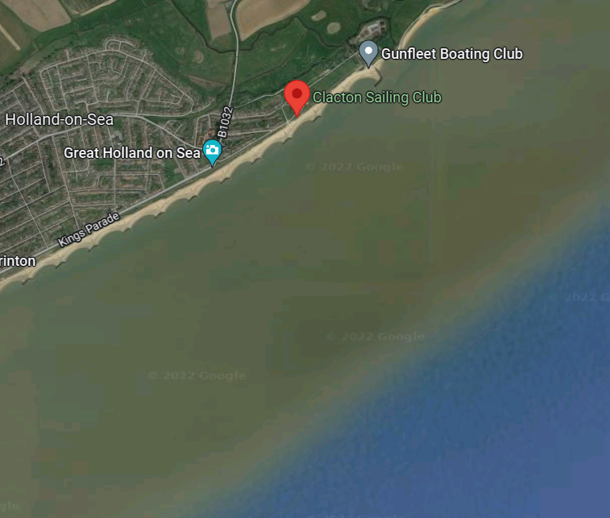
Sailing area

